Borrowable Medical Equipment List

Item | Graphic | Inventory
Axillary  Crutch | 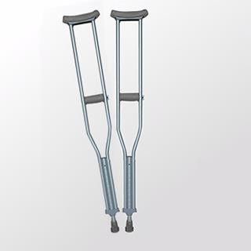 | 30（Pair）
General  Wheelchair | 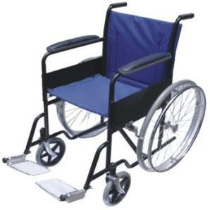 | 4
Orthopedic  Wheelchair | 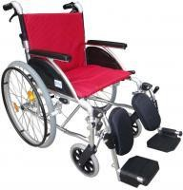 | 4

First  Aid  Box | 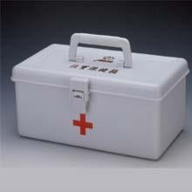 | 5（Large）  10（Small）
Sports Protection  Box | 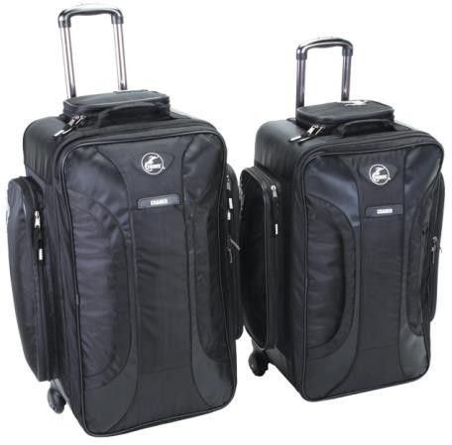 | 4（Box）
First Aid Waist Pack | 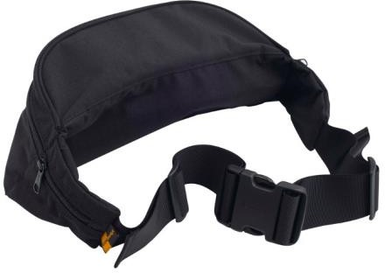 | 30

